Good Morning Everyone,

Just a reminder that the Voting Centre will open tomorrow!
Voting will be open from Tuesday, July 13 ( 9:00 am) - Thursday, July 15 (5:00 pm) .

Voting can only be accessed via VOTING CENTRE online through the Provincial OSSTF website.

To vote login in to: Member Login (osstf.on.ca)

Then click
Once there, you will see 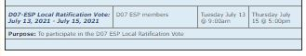

Click ballot button to cast your vote 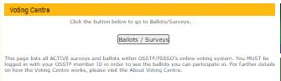

We encourage all eligible members to vote.

On behalf of the ESP Negotiating Table Team...
Thank you for taking the time to vote, have a safe and wonderful summer!

Michelle Phillips

OSSTF District 7 ESP BU
Chief Negotiator/Grievance Officer
Educational Services Officer

michelle_phillips@rogers.com

